📄 **MongoDB Schema Design Overview – Online Learning Platform**

|  |  |
| --- | --- |
| **Collection** | **Description** |
| users | Stores all users including students, instructors, and admins. |
| courses | Stores course metadata, each course has one instructor. |
| lessons | Lessons for each course, ordered and linked by course_id. |
| exams | One exam per course with nested questions array. |
| enrollments | Tracks student enrollments for each course. |

**Schema Design**

**1. users Collection**

The users collection stores information about users in the platform. Users can be students, instructors, or admins.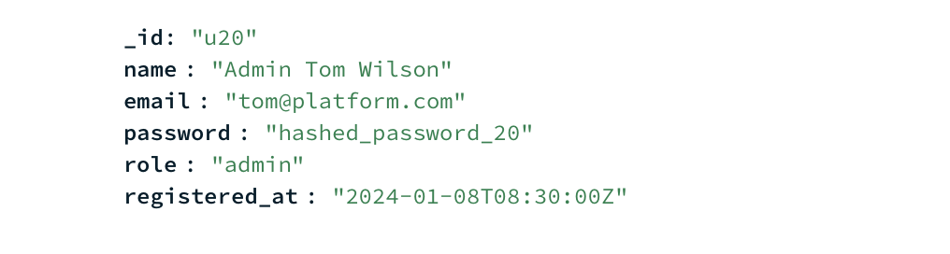

* **_id**: Unique user ID.
* **name**: User's name.
* **email**: User's email.
* **Password:** User’s password
* **role**: Role of the user (student, instructor, admin).
* **registered_at**: Timestamp of when the user registered.

**2. courses Collection**

The courses collection stores details about courses. Each course has a reference to an instructor (instructor_id), which is linked to a record in the users collection.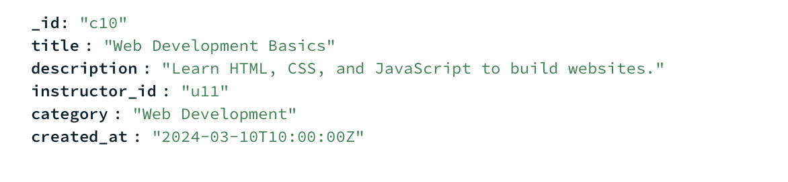

* **_id**: Unique course ID.
* **title**: Title of the course.
* **description**: Short description of the course.
* **instructor_id**: Reference to the instructor in the users collection.
* **category**: Category of the course (e.g., Programming, Data Science).
* **created_at**: Timestamp when the course was created.

**3. lessons Collection**

The lessons collection represents individual lessons within a course. Each lesson is associated with a course (course_id), and the lessons are ordered by order_number.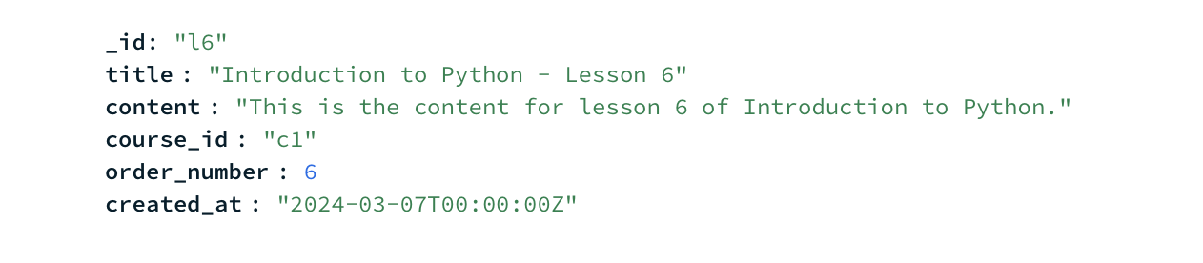

* **_id**: Unique lesson ID.
* **title**: Title of the lesson.
* **content**: Text content of the lesson.
* **course_id**: Reference to the course in the courses collection.
* **order_number**: The sequence number of the lesson within the course.
* **created_at**: Timestamp when the lesson was created.

**4. exams Collection**

The exams collection stores exam details for each course. Each exam has multiple questions, each with options and a correct answer.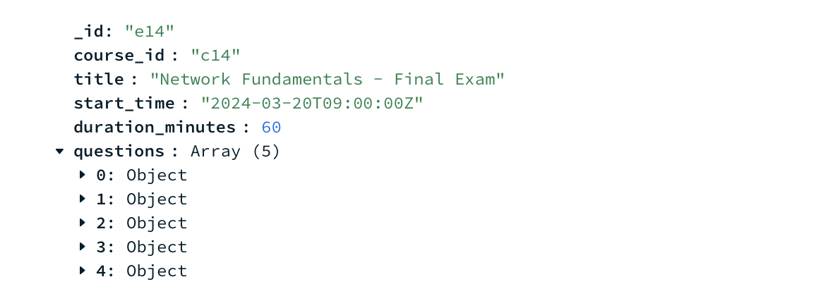

* **_id**: Unique exam ID.
* **course_id**: Reference to the course in the courses collection.
* **title**: Title of the exam.
* **start_time**: The start time of the exam.
* **duration_minutes**: Duration of the exam in minutes.
* **questions**: An array of questions, each with possible options and the correct answer.

**5. enrollments Collection**

The enrollments collection tracks which students are enrolled in which courses. It includes the enrollment status and the enrollment timestamp.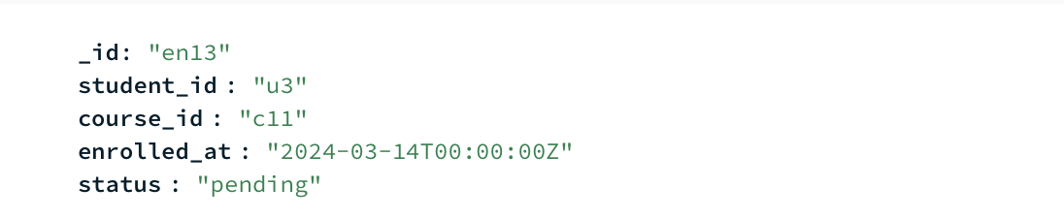

* **_id**: Unique enrollment ID.
* **student_id**: Reference to the student in the users collection.
* **course_id**: Reference to the course in the courses collection.
* **enrolled_at**: Timestamp when the student enrolled in the course.
* **status**: Enrollment status (active, pending).